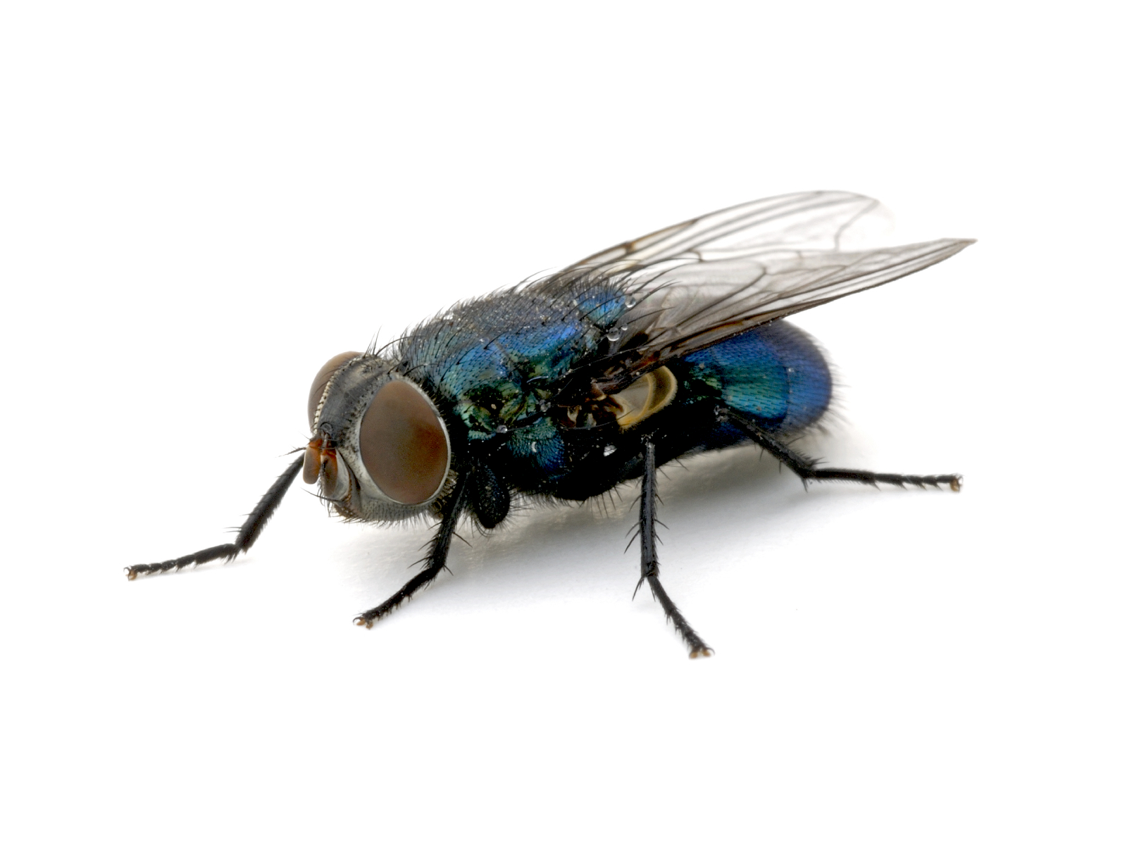

WOULD A FLY WITHOUT WINGS   
BE CALLED A WALK?



WOULD A FLY WITHOUT WINGS   
BE CALLED A WALK?

[Firm Name]

[Address]

[City, State Zip]

**[Name]**

**[Address]**

**[City, State Zip]**

[Firm Name]

[Address]

[City, State Zip]

**[Name]**

**[Address]**

**[City, State Zip]**