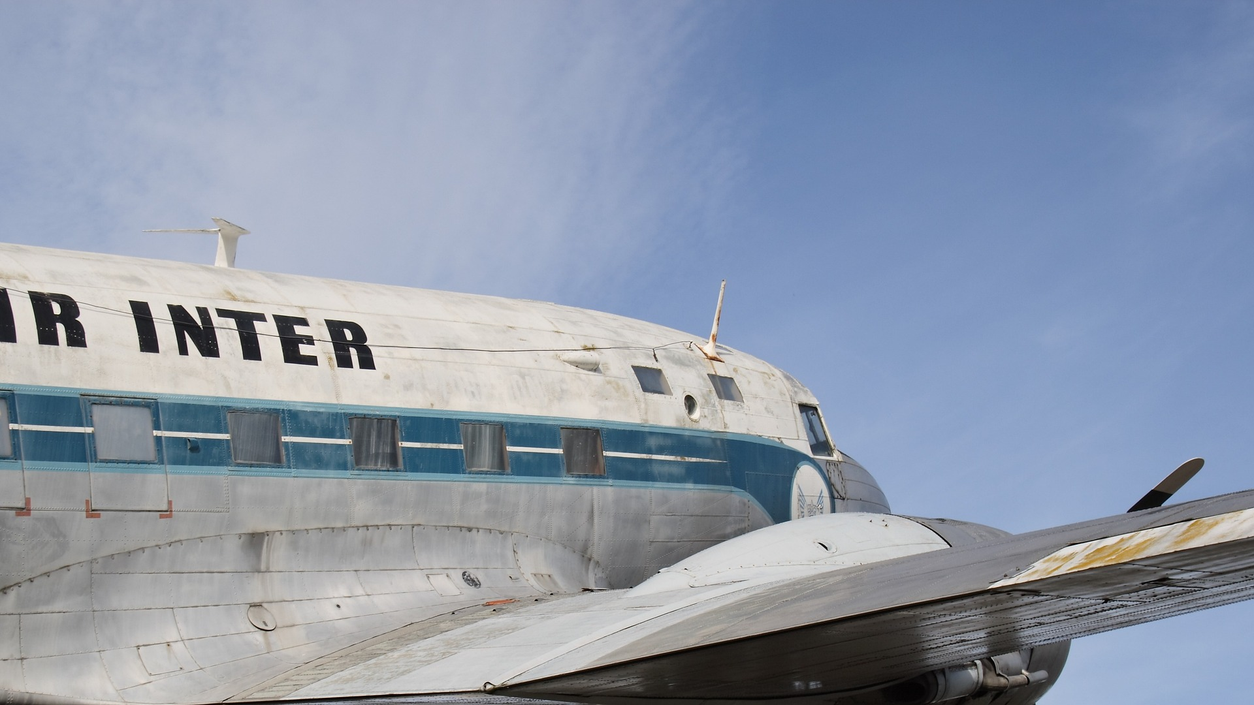

If the “black box” flight recorder isn’t damaged in a crash, why don’t they make the whole plane out of the stuff?



If the “black box” flight recorder isn’t damaged in a crash, why don’t they make the whole plane out of the stuff?

[Firm Name]

[Address]

[City, State Zip]

**[Name]**

**[Address]**

**[City, State Zip]**

[Firm Name]

[Address]

[City, State Zip]

**[Name]**

**[Address]**

**[City, State Zip]**