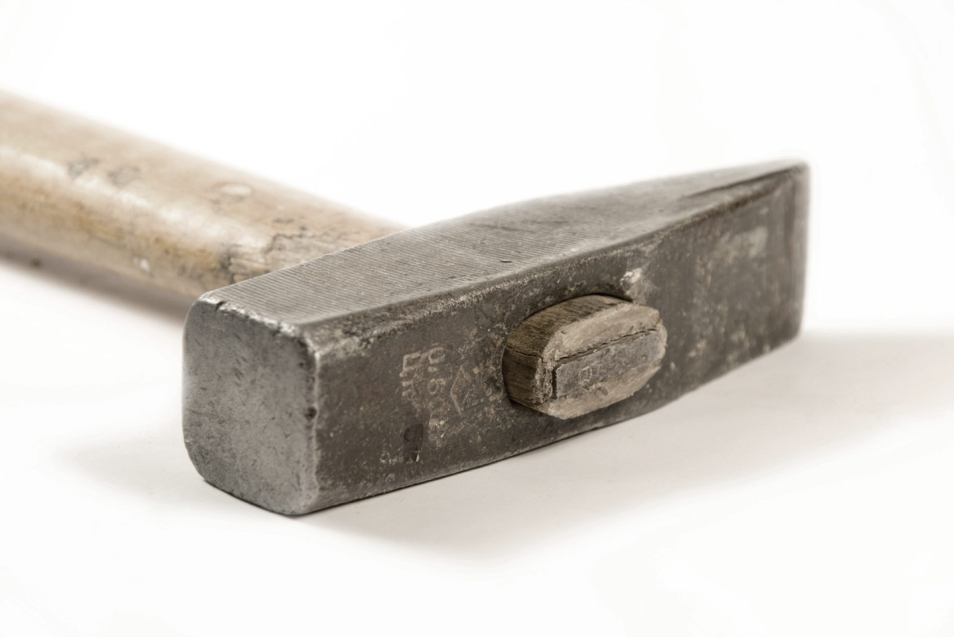

Why do we say something is   
“Out of Whack”?

What is Whack?



Why do we say something is   
“Out of Whack”?

What is Whack?

[Firm Name]

[Address]

[City, State Zip]

**[Name]**

**[Address]**

**[City, State Zip]**

[Firm Name]

[Address]

[City, State Zip]

**[Name]**

**[Address]**

**[City, State Zip]**